Vocation and Calling:
Rethinking Responsibility in Healthcare
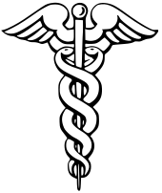
Thursday, April 4, 2019
4:15pm, Bryant Hall 111

Margaret E. Mohrmann, MD; PhD
Professor Emeritus of Religious Studies,
Affiliate faculty in the Bioethics Program
& the School of Medicine,
University of Virginia

Light refreshments will be served. Please RSVP to cps@olemiss.edu by April 2, because space is limited.

This event is co-sponsored by the Society and Health Interdisciplinary Minor housed in the Center for Population Studies, by the Department of Philosophy & Religion, and with funds from the University Lecture Series.

